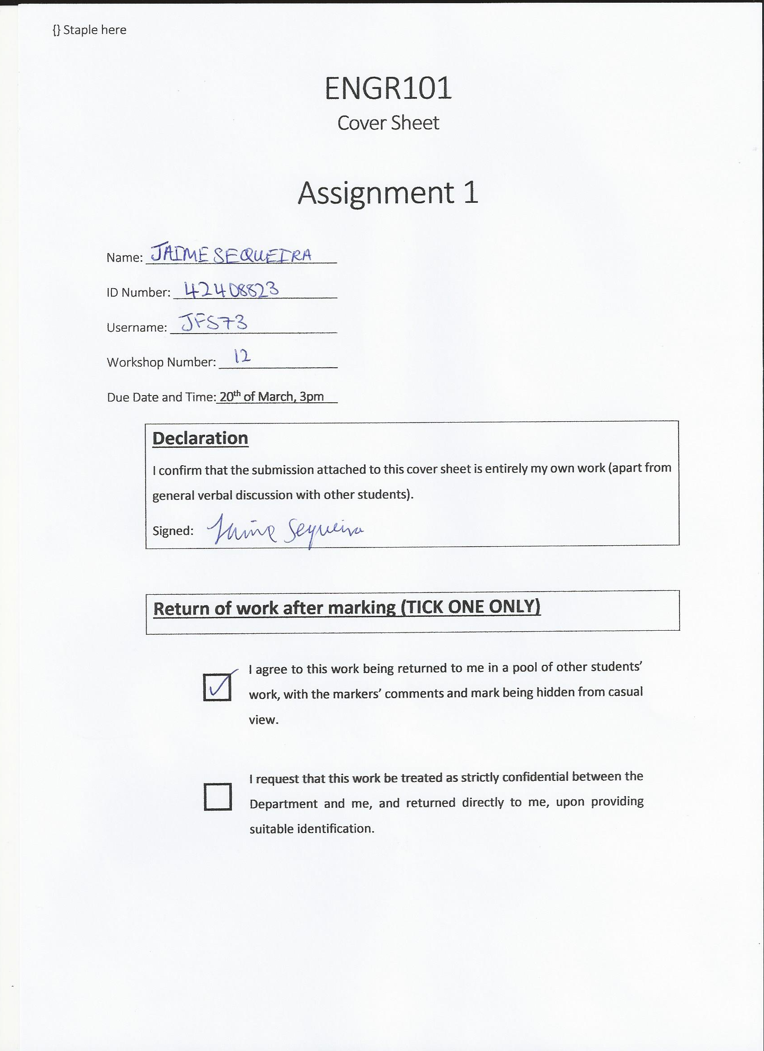

**Marking Schedule**

**Content (Summary, Introduction, Technical Information, Conclusions)**

Content does not relate well to the subject, very little useful information. 1, 2

A small amount of content but insufficient to meet the aim of the report. 3

Good but some sections poor or minimal information. 4

Mostly good but room for improvement in one aspect. 5, 6, 7

Clear content, good summary, full of relevant information, good conclusion 8, 9, 10

**Grammar (grammar, punctuation, spelling, word choice)**

There are a number of different problems in grammar, spelling and/or punctuation, and communication is not effective or report is difficult to read and understand. 1

Readable but a number of improvements are possible. 2

A small number of improvements are possible. 2.5

Correct in all aspects. Difficult to improve further 3

**Format (Consistent typographical standard, spacing, headings)**

Inconsistent or distracting formatting that makes reading difficult. 1

Room for improvement 2

Very effective format that makes reading easy. Paragraphs correct, title page. 3

**Graph(s) (Clear, axes labelled, appropriate caption underneath)**

No graphs or very many improvements required 0

Room for improvement 1

Very clear, uncluttered, professional appearance, appropriate caption. 2

**Table(s) (Clear, uncluttered, units shown, appropriate caption above)**

No tables or very many improvements required 0

Room for improvement 1

Very clear, uncluttered, professional appearance, appropriate caption above. 2

**Citation and Referencing (Range of sources, citations, references)**

Not cited within text or referenced at all or very poor citation. 0

Only one of the three parts (range of sources, citations, references) has been done well. 1

Two parts done well or room for improvement. 1.5

Proper APA citation and referencing format used. All references are cited in the report.   
A good range of sources (≥ 5) are used. 2

**Penalties: no marking sheet (-1), word count (-1, -2)**

**Total Mark /22**

Marker’s initials:

Technical Report Regarding Aircraft Overweight Issues and Comfort

Jaime Felipe Sequeira

ENGR101

Foundations of Engineering

2017

University of Canterbury

Word Count: 998

Table of Contents

Summary ii

Introduction 1

The Problem 1

Define Success 2

The Selected Solution 3

Test 3

Conclusions 4

References 6

# Summary

Due to the mean weight of both males and females, aircrafts are reaching their maximum floor loading capacity (kg/m²). The solution to this problem is to replace some current rows of seats with single, wider seats. Heavier customers would be able to select this option as their seat when booking their flight. The aisle width must remain within the threshold set by the Civil Aviation Authority (between 12 to 20 inches depending on the aircraft type). There are five main constraints that would need to be met by this solution. These are: passing the safety standard required by the Civil Aviation Authority of New Zealand (CAA); customer service must be improved; the current fleet of aircraft must still be used and finally it must not take too long to implement the solution. These criteria would be met by having the CAA inspect the aircraft, running trials for the new arrangement of seats and upgrading one aircraft at a time.

# Introduction

Research (Ministry of Health New Zealand, 2016) shows that the mean weight of both males and females in New Zealand has been increasing since 2006. This is a problem as when flights are fully booked, this excess weight means that the total floor loading is reaching its maximum. This report focuses on how to comply with safety requirements issued by the Civil Aviation Authority of New Zealand when an aircraft has reached its maximum floor loading. It also focuses on how to make sure customers of commercial airlines are still happy after the solution is implemented.

# 

Figure 1: The mean weight of both male and females in New Zealand from 2006-20016.

# The Problem

“Studies show that the average weight of air passengers increased from 72 kg (female) and 84 kg (male) to 75 kg and 89 kg, respectively, since 1990s. There are potential safety issues due to the weight of total passengers exceeds the manufacturer’s ultimate floor loading (kg/m2) for the existing old aircrafts when they are fully booked. While the airlines must comply with the safety standards, the basic passenger needs are not to be overlooked. The airlines are required to come up with a solution to address this issue.” (ENGR101 Assignment Briefing Sheet, 2017)

Technical Information

# Define Success

The following are a set of constraints and performance criteria for the solution:

* The solution must comply with all the safety standards for commercial airlines created by the Civil Aviation Authority of New Zealand (CAA).
* Customer satisfaction must be increased.
* The current fleet of aircraft must not be changed.
* The solution must not take too much time to implement. Taking too much time would cripple airline profit margins due to their aircraft not being able to be used during this time. ([Adamczyk](http://time.com/money/author/alicia-adamczyk/), 2015)

The Selected Solution

Decrease the total quantity of seats in the aircraft but make some seats wider. This is achieved by replacing selected rows of seats with one seat that is the width of that row. This decreases the number of people that are able to board a fully booked aircraft. Therefore, the threshold of the ultimate floor loading (kg/m²) is not exceeded.

Test

Comply With Safety Standards

The current standards for the minimum aisle width of an Aircraft are shown in the table below (Table 1). The aircraft would be inspected by CAA officials. The width of the aisle would not be changed by the new design as the bigger seats are just the size of the regular row of seats combined. It is guaranteed that this solution would pass the CAA minimum aisle width standard. The seats for the larger people would be Type C-U in order to support a load of around 86kg (AS8049, Regulation, 2015). To test that the Aircraft complies with the ultimate loading for take-off, the Aircraft would be weighed with its maximum passenger capacity.

Table 1: The minimum passenger aisle width required in an aircraft. (ARP5526D, Aircraft seat design guidance and clarifications, 2015)

|  |  |  |
| --- | --- | --- |
| Number of Passenger Seats | Minimum Passenger Aisle Width (Inches) | |
|  | Less than 25 inches from floor | More than 25 inches from floor |
| 10 or less | 12 | 15 |
| 11 through 19 | 12 | 20 |
| 20 or more | 15 | 20 |

Customer Satisfaction

One method to test this solution and see if it meets the customer satisfaction level required would be to have representatives from the public test the new seating arrangement. They would book their test flight just like anyone would book a normal flight. They would enter their weight and the heavier people have the option to sit in the wider seats (they have the option so it does not seem to confronting). On this test flight, the normal services would run (beverages and food). Upon completion, the testers would provide feedback on their experience via an online survey and the airline company could see what needs to be improved to improve the customer satisfaction level.

Current Aircraft Are Used

Each Aircraft would be upgraded one at a time. Since the weight of the aircraft would be reduced due to there being less seats, there would be no reason to need to upgrade any other components of the aircraft or to purchase new Aircraft. The current fleet would still be used.

Time Required For Implementation

Implementing this solution must not take long. In order to decrease the time required, the wider seats would be prefabricated. The new seats would be a direct replacement for the old ones and could be bolted straight on. To reduce the time taken to install the seats, there would be training sessions for each upgrade crew. During these times, they would assemble the same seats in the same order but on a trial aircraft or in a training room.

# 

# Conclusions

These are the four main constraints/ performance criteria would be needed to be met in order to fix this issue:

1. The upgraded aircraft must comply with the safety standards set out by the Civil Aviation Authority of New Zealand.
2. Customer service must not be hindered in any way by the solution. It should be improved compared to what it was before.
3. The current fleet of aircraft must still be used. There is no extra budget to buy new aircraft so the current ones must be modified.
4. The solution must not take too much time to be implemented. Wasting time is also wasting the profits of the airline company.

The best way to achieve all these constraints would be to make some rows of seats into single, wider seats. This makes sure that the aircraft passes the safety requirements but customer satisfaction is still a priority.

# References

Ministry of Health New Zealand. (2016). Mean Weight Statistics. Retrieved from: <https://minhealthnz.shinyapps.io/nz-health-survey-2015-16-annual-update/>

ARP5526D. Aircraft seat design guidance and clarifications. 2015. Standard. SAE International.

[Adamczyk](http://time.com/money/author/alicia-adamczyk/), 2015. Airline Profits Rise for North American Carriers, Less So in Europe and Asia | Money. (n.d.). Retrieved March 19, 2017, from: <http://time.com/money/3914325/airline-profits/>

AS8049. Regulation. 2015. Standard. Performance Standard for Seats in Civil Rotorcraft, Transport Aircraft, and General Aviation Aircraft.

ENGR101 Assignment Briefing Sheet. Ver_final. 2017